**Trabajo Practico**

**Alumno:** Santiago Vietto

**Materia:** Lenguajes Formales y Automatas

Clave: 1802890

**Año:** 2020

**Ejericio 1:**

|  |  |  |
| --- | --- | --- |
| f | a | b |
| >Q1 | Q2 | Q3 |
| Q2 | Q4 | Q4 |
| Q3 | Q4 | Q4 |
| Q4* | Q2 | Q2 |

* Este caso es conexo
* Conjuntos: C1 = {Q1, Q2, Q3} C2 = {Q4}

f(Q1, a)=Q2 ϵ C1

f(Q1, b)=Q3 ϵ C1

f(Q2, a)=Q4 ϵ C2

f(Q2, b)=Q4 ϵ C2

f(Q3, a)=Q4 ϵ C2

f(Q3, b)=Q4 ϵ C2

* Q2 y Q3 son equivalentes pero Q1 con Q2 no, y Q1 con Q3 no
* Nuevos conjuntos C1 = {Q1} C2={Q2, Q3} C3 = {Q4}

f(Q2, a)=Q4 ϵ C3

f(Q2, b)=Q4 ϵ C3

f(Q3, a)=Q4 ϵ C3

f(Q3, b)=Q4 ϵ C3

|  |  |  |
| --- | --- | --- |
| f | a | b |
| >C1 | C2 | C2 |
| C2 | C3 | C3 |
| C3* | C2 | C2 |

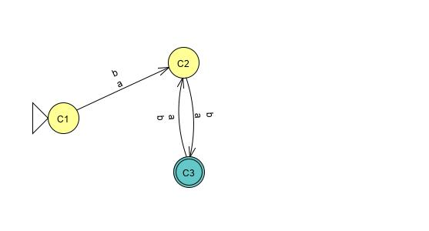

**Ejericio 2:**

|  |  |  |
| --- | --- | --- |
| f | a | b |
| >Q1 | Q2 | Q1 |
| Q2 | Q3 | Q3 |
| Q3* | Q2 | Q2 |
| Q4* | Q3 | Q4 |

* Este caso no es conexo, entonces lo elimino
* Conjuntos: C1 = {Q1, Q2} C2 = {Q3}

f(Q1, a)=Q2 ϵ C1

f(Q1, b)=Q1 ϵ C1

f(Q2, a)=Q3 ϵ C2

f(Q2, b)=Q3 ϵ C2

* Q1 y Q2 no son equivalentes
* Nuevos conjuntos C1 = {Q1} C2={Q2} C3 = {Q3}

f(Q1, a)=Q2 ϵ C2

f(Q1, b)=Q1 ϵ C1

f(Q2, a)=Q3 ϵ C3

f(Q2, b)=Q3 ϵ C3

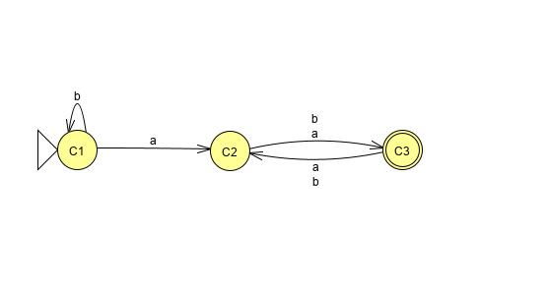

|  |  |  |
| --- | --- | --- |
| f | a | b |
| >C1 | C2 | C1 |
| C2 | C3 | C3 |
| Q3* | C2 | C2 |

**Ejericio 3:**

|  |  |  |
| --- | --- | --- |
| f | a | B |
| >Q1 | Q2 | Q3 |
| Q2 | Q4 | Q4 |
| Q3 | Q4 | Q4 |
| Q4* | Q5 | Q5 |
| Q5 | Q5 | Q5 |

* Este caso es conexo
* Conjuntos: C1 = {Q1, Q2, Q3,Q5} C2 = {Q4}

f(Q1, a)=Q2 ϵ C1

f(Q1, b)=Q3 ϵ C1

f(Q2, a)=Q4 ϵ C2

f(Q2, b)=Q4 ϵ C2

f(Q3, a)=Q4 ϵ C2

f(Q3, b)=Q4 ϵ C2

f(Q5, a)=Q5 ϵ C1

f(Q5, b)=Q5 ϵ C1

* Q2 y Q3 son equivalentes pero Q1 con Q2 no, y Q1 con Q3 no, y Q5 no es equivalente a Q4 por que no pertenece al conjunto de salida.
* Nuevos conjuntos C1 = {Q1} C2={Q2, Q3} C3 = {Q4} C4={Q5}

f(Q2, a)=Q4 ϵ C3

f(Q2, b)=Q4 ϵ C3

f(Q3, a)=Q4 ϵ C3

f(Q3, b)=Q4 ϵ C3

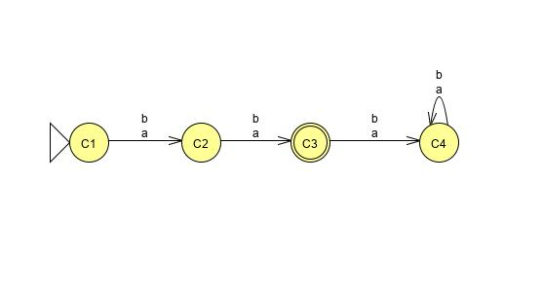

|  |  |  |
| --- | --- | --- |
| f | a | b |
| >C1 | C2 | C2 |
| C2 | C3 | C3 |
| C3* | C4 | C4 |
| C4 | C4 | C4 |

**Ejericio 4:**

|  |  |  |
| --- | --- | --- |
| f | a | B |
| >C* | D | A |
| D | B | B |
| A | B | B |
| B | C | E |
| E | D | D |

* Este caso es conexo
* Conjuntos: C1 = {D, A, B,C} C2 = {C,E}

f(C, 0)=D ϵ C1

f(C, 1)=A ϵ C1

f(D, 0)=B ϵ C1

f(D, 1)=B ϵ C1

f(A, 0)=B ϵ C1

f(A, 1)=B ϵ C1

f(B, 0)=E ϵ C2

f(B, 1)=E ϵ C2

* D y A son equivalentes.
* Nuevos conjuntos C1 = {C} C2={A, D} C3 = {B} C4={E}

f(Q2, 0)=Q4 ϵ C3

f(Q2, 1)=Q4 ϵ C3

f(Q3, 0)=Q4 ϵ C3

f(Q3, 1)=Q4 ϵ C3

* Pero C1 y C4 tambien son equivalentes, entonces:

C1 = {C,E} C2={A, D} C3 = {B}

f(C1, 0)=C2

f(C1, 1)=C2

f(C4, 0)=C2

f(Q3, 1)=C2

Y ademas pertenecen al conjunto de salida

|  |  |  |
| --- | --- | --- |
| f | 0 | 1 |
| >C1* | C2 | C2 |
| C2 | C3 | C3 |
| C3 | C1 | C1 |

